The Chat Application

Requirements Document

Table of Contents

1 Introduction 3

1.1 Purpose and Scope 3

1.2 Target Audience 3

1.3 Terms and Definitions 3

2 Product Overview 4

2.1 Users and Stakeholders 4

*2.1.1 Users 5*

*2.1.2 Developer 5*

2.2 Use cases 5

*2.2.1 Register 5*

*2.2.2 Log In 5*

*2.2.3 Public Chat 6*

*2.2.4 Private Chat 7*

*2.2.5 Access Chat Records 7*

*2.2.6 Log Out 8*

3 Functional Requirements 9

3.1 Register 9

3.2 Log In 9

3.3 Chat 10

*3.3.1 Public 10*

*3.3.2 Private 10*

3.4 Access Chat Records 10

3.5 Log Out 10

4 Nonfunctional Requirements 11

4.1 Platform 11

4.2 Scalability 11

5 Milestones and Deliverables 12

5.1 Design Documentation 12

*5.1.1 Analysis 12*

*5.1.2 Design 12*

5.2 Test Plan 13

5.3 Project Report and Final Deliverables 13

# Introduction

## Purpose and Scope

The purpose of this document is to describe the Chat Application that will be built. It will describe the product overview, including all stakeholders and use cases. It will also describe all function requirements as well as all nonfunctional requirements. Finally, this document will explain the milestones and deliverables of the application.

This application will allow users to register for the app to log in and access the chat environments. This application will also allow users to communicate with all other users registered in a public chat environment while also allowing personal one-to-one chats with individual users in a private chat environment not accessible by other users. Users will also be able to access past conversations they have had with other users. Users will also be able to log out of the application.

## Target Audience

The target audience for this application is anyone who enjoys online communication without needing to know with whom they are talking.

## Terms and Definitions

|  |  |
| --- | --- |
| Chat Environment | an area where messages received are displayed for other chatters. |
| Records Environment | an area where previous posts are printed for chatters to view. |
| Chatter 1 | a user of the application. |
| Chatter 2 | one other user. |
| Chatter N | one or more other users. |
| ID | user name chatter wants to be identified as. |

# Product Overview

This section will describe users, stakeholders, and use cases. Users are defined as anyone registered and communicating on this application. Stake holders are anyone involved in the development, deployment, use, maintenance, etc. of the software. A use case is any interaction between the user and the software. This application will not employ emoji’s or any flagging system for inappropriate content and users will not be able to change their ID or password. They must create a new user if they wish to change one of said items.

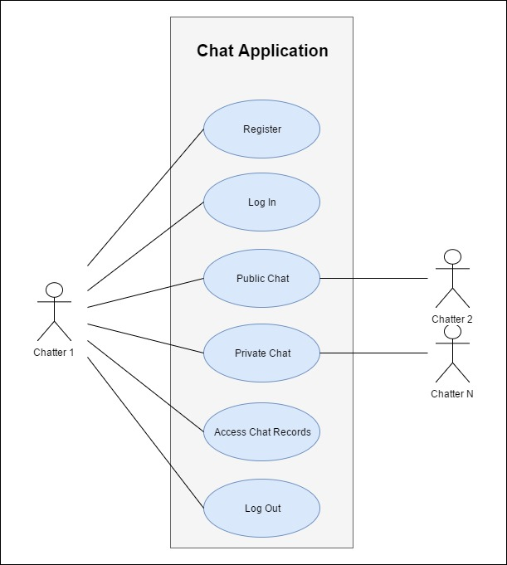

## Users and Stakeholders

The purpose of this section is to identify users and stakeholders.

### User

The user’s role is to access and communicate with other users in the chat application.

### Developer

The developer is in charge creating, deploying, and maintaining the chat application.

## Use cases

The purpose of this section is to give a detailed view of the functionality of the application.

### Register

Chatter 1 enters ID and password and the Register use case will create a new account.

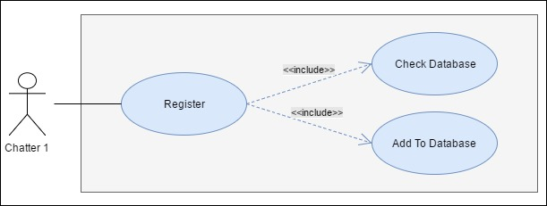

**Brief Description**

The *Register* use case allows Chatter 1 to register to the application. The *Check Database* use case allows the *Register* use case to determine if the chatter is not already registered. The *Add To Database*use case allows the *Register* use case to register a new chatter to the application.

**Step-by-Step Description**

1. Ask for user ID.
2. Ask for a password.
3. Check ID against database utilizing use case Check Database.
4. Add user to database.

### Log In

Chatter 1 enters ID and password. Log in verifies Chatter 1 has registered and marks Chatter 1 as logged in, allowing Chatter 1 to access chat environments.

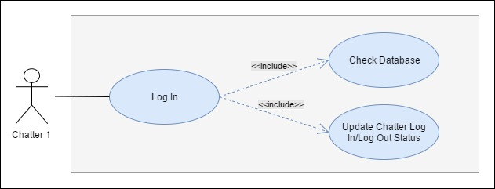

**Brief Description**

The Log In use case allows Chatter 1 to log in to the application. The Check Database use case allows Chatter 1 allows the Log In use case to verify that Chatter 1 has registered. The Update Chatter Log In/Log out Status use case allows Log In use case to log in Chatter 1.

**Step-by-Step Description**

1. Verify that chatter is a registered member using use case Check Database.
2. Update chatter as logged in using use case Update Chatter As Logged In.

### Public Chat

Chatter 1 requests access to public chat environment. Public Chat opens and adds Chatter 1 to public chat environment. Chatter 1 reads messages from Chatter N, types a message and posts to the public chat environment.

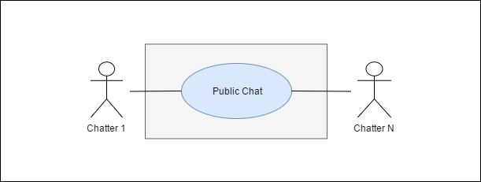

**Brief Description**

The Public Chat use case allows Chatter 1 to communicate with Chatter N in a public chat environment.

**Step-by-Step Description**

1. Open public chat environment for Chatter 1.
2. Type, post, and read messages.

### Private Chat

Chatter 1 requests access to private chat environment with Chatter 2. Private Chat opens private chat environment and adds Chatter 1 and Chatter 2 to environment. Chatter 1 and Chatter 2 read, type, and post messages.

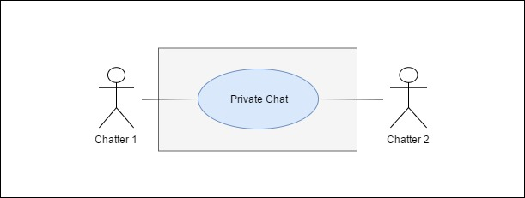

**Brief Description**

The Private Chat use case allows Chatter 1 to communicate with Chatter 2 in a private chat environment.

**Step-by-Step Description**

1. Open private chat environment for Chatter 1 and Chatter 2.
2. Type, post, and read messages.

### Access Chat Records

Chatter 1 requests previous posts. Access Chat Records returns record environment. Chatter 1 views previous posts.

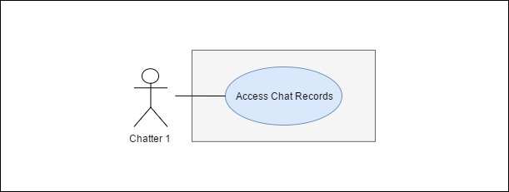

**Brief Description**

The Chat Single User use case allows Chatter 1 to look at previous chat records.

**Step-by-Step Description**

1. Retrieve chat records for chatter.
2. Display chat records on screen.

### Log Out

Chatter 1 requests to log out of chat application. Log Out changes Chatter 1 status to logged out.

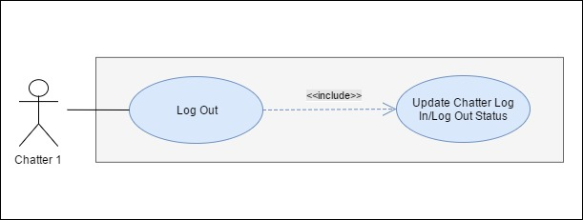

**Brief Description**

The Update Chatter Log In/Log Out Status use case allows the Log Out Chatter 1 to log out of the application.

**Step-by-Step Description**

1. Update chatter as logged out.

# Functional Requirements

Listed below are the functional requirements for the chat application. A functional requirement is a feature the application must perform.

## Create New Account

Create New Account allows a chatter to set up an ID and password to access features in the chat application.

### Register

Chatter will click on the *register* link on the main screen. The system will ask the chatter to enter an ID and password to identify them. The system searches account database to determine that the given ID is available. If the ID does not already exist, a new account is created. If the ID already exists, the system will inform the chatter the ID is unavailable and prompt them to enter different ID. Once the account is created, the system directs chatter to the member screen which displays all chatters currently logged in and a link to the public chat environment.

## Log In

Chatter will click on the *log in* link on the main screen. The system will ask the chatter to enter their ID and password. The system will search the account database for the given ID. If the ID exists, the system will compare the password entered with the password on file. If the ID does not match any in the database or the ID does match but the password entered does not match the password on file, the system will prompt the chatter to re-enter an ID and password. Once the ID and password match, the system directs chatter to the member screen which displays all chatters currently logged in and a link to the public chat environment.

## Chat

Chatter 1 has two options of which chat environments to access. A public chat environment to message with all other logged in chatters and a private chat environment to message individual chatters.

* + 1. **Public Chat**

Chatter 1 clicks on *enter chat* link on member page. The system opens the chat environment for Chatter 1. Chatter 1 reads, types, and posts messages to the environment. The system posts all other chatters messages in environment.

## Private Chat

Chatter 1 clicks on logged in viewer listed on member page. The system opens private chat environment for Chatter 1. The system asks Chatter 2 if they would like to join private chat environment. Chatter 2 clicks *accept* or *deny* links on invite screen. If Chatter 2 accepts invitation, the system opens the private chat environment for Chatter 2. If Chatter 2 denies invitation. The system closes the invite screen for Chatter 2, informs Chatter 1, and closes private chat environment.

## Access Chat Records

Chatter 1 clicks *access posts* link on member page. The system searches Chatter 1 history and displays them on records screen.

## Log Out

Chatter 1 clicks *Log Out* link on member page. The system will search the account database and updates the user as logged out. The system returns the user to the main screen.

# Nonfunctional Requirements

This section will describe the nonfunctional requirements of the application. Nonfunctional requirements identify properties of the application

## Platform

This application will be written in Java code and will run on IntelliJ Idea 2016.3.4(64). It will implement the IntelliJ graphical user interface (GUI).

## Scalability

This application must be able to support at least one hundred users

# Milestones and Deliverables

This section communicates the major due dates for each workflow of the project. The milestones for this application are Design Document, Test Plan, and Project Report and Final Deliverables. Below is a Gantt chart illustrating each timeframe.

## Design Document

This milestone consists of two stages: analysis and design. Analysis will determine which classes will be required for this application. Design will determine what data structures will be implemented in the application.

### Analysis

Classes will be determined in this stage and a class diagram will be created.

### Design

The data structures which will be implemented will be determined in this stage and a design document will be delivered.

## Test Plan

During this section, the design documentation will be compared to the requirement documentation to ensure that all the requirements of the application have been satisfied.

## Project Report and Final Deliverables

The application and all documentation will be delivered at this time.